Raja Ali Hassan  
  
 Theory of Programming Languages

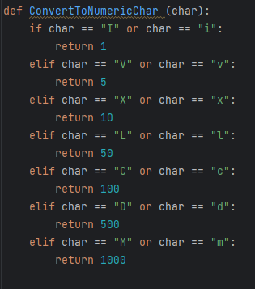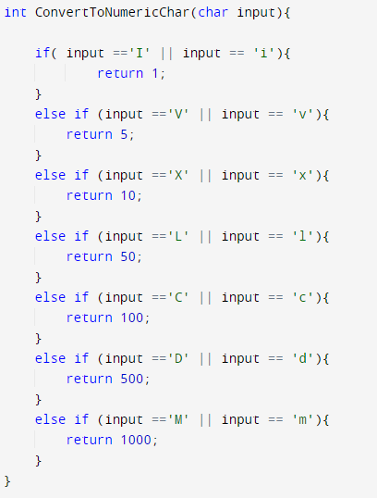The task of Roman Number addition and subtraction was implemented in Python and C++ language respectively. Both languages being one of the most popular frameworks for implementing such logical structure due to their functional and Hybrid strategies. Upon implementing the same task in both language there were clearly some differences in terms of Readability, Writability and Reliability, as discussed below.  
  
Readability   
 C++ in comparison to python turns out to be much more readable. Due to the clear declarations of variable data types, functions parameters and function return values.

Above both function (Left: Python) (Right: C++) that takes in a character and upon some validation return the appropriate value. It can be seen clearly that in python there are no data types mentioned. Neither in function parameters section nor in return type, while on other hand C++ everything is clearly mentioned which makes it easier to understand what arguments are to be given and which kind of output is expected.

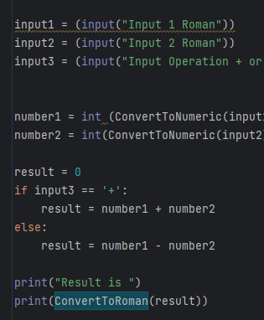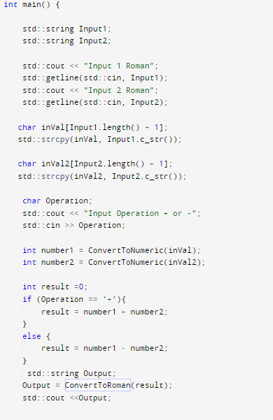

Same kind of situation can be seen in above code snippets as well. These refer the main function of both languages. In C++ variables are declared with data types mentioned while in Python data types are not mentioned which are dynamically typed. In terms of readability C++ definitely takes the lead due to the explicit declaration of all variable data types and function(s) return type.  
  
In C++ structure is very clearly separated from each other using curly braces while in python it is solely done on the basics of dentation which often times results in difficulty for understanding the code segments.

Writability

 In terms of Writability among both languages Pythons comes out with a lead over C++, due to its dynamically typed variable, function parameters and function return types. This allows the developer to not focus on the syntax on the program but to actually focus on the task at hand.

In above example of the main function of both (Python on Left) and (C++ on Right). It can be seen that in C++ in order to take input in string from user you need to first take input in the string data type and then convert it into array of characters in order to pass it to the function, whilst in python there is no such need due to its dynamically structured arrays. As C++ is a strong typed languages data types are not compatible with each other everything has to be converted into a specific form in order to perform operation on it.

Reliability  
  
 In terms of reliability C++ again takes a lead on python. As all data types are checked at the compile time type so in case of any disputed data type is informed on the compile time. In python due to it being a dynamically typed language there can be some issue in the run time. For example, a function which is designed to handle strings and if the user inputs an integer in it will allow it to be taken in and processed but during the processing it will result in error as we are feeding an integer to a function which is for string. In such scenarios C++ is reliable as it will throw an error before feeding the data into a function declaring the data types do not match, while in python there is no such thing. In result C++ comes out to be the winner here as well.